**EZPAY: AUTOMATED FARE COLLECTION SYSTEM USER MANUAL**



IMPLEMENTATION OF HAVERSINE, DIJKSTRA’S ALGORITHM, AND

SARIMAX FOR PHILIPPINE TRANSPORT AND

FARE COLLECTION SYSTEM

User Manual

by

Audrey B. Salcedo

Bea Merr S. Recabar

Clarice Jane D. Darle

Tina Marie F. Santisteban

May 20

**DISCLAIMER**

By downloading, accessing or using the systems you signify your assent to this disclaimer. The content of these systems, including without limitation, all data, text, graphics, links and other materials are provided as a convenience to our system users and are meant to be used for operational purposes only, we do not take responsibility for decisions taken by the user based solely on the information provided in these systems. The developers have made every attempt to ensure the accuracy and reliability of the information on these systems. We cannot and will not guarantee that these systems are free from computer viruses or anything else that has destructive properties. We shall not be liable for any loss or damage of whatever nature (direct, indirect, consequential, or other) whether arising in contract, tort or otherwise, which may arise as a result of (or inability to use) these systems, or from your use of (or failure to use) the information of these systems. No warranties, promises, and/or representation of any kind, expressed or implied, are given as to the nature, standard, accuracy or otherwise the information provided in these systems nor the suitability or otherwise of the information to your particular circumstances.

**TABLE OF CONTENTS**

Disclaimer 3

Table of Contents 4

Getting Started 5

Introduction 5

System Requirements 6

Installation 7

Usage 10

Troubleshooting 14

FAQ (Frequently Asked Questions) 16

Contact Details 18

GUIDE FOR DEPLOYING AND USING THE SYSTEM’S MAIN FUNCTION

GETTING STARTED

INTRODUCTION

This manual is designed to guide and provide documentation to users who will use the developed systems of the said study. These said systems are coexisting and aim to help in modernizing the transportation system here in the Philippines. The features, functionalities, and other information are documented here to be accessed by readers, specifically future researchers and developers to help guide them navigate and to better understand this study. The said three systems are the loading system, fare management system, and the automated fare collection mobile application. The loading system is designed to allow the users of the automated fare collection mobile application to top up their accounts. Meanwhile, the automated fare collection system is designed mainly to generate tickets and claim payments via qr code with additional features such as simulating shortest path using dijkstra’s algorithm. Lastly, the fare management system is designed for monitoring and managing the loading system for the administrators to use with sales prediction from SARIMAX Algorithm which is integrated to the said system. The develop systems are interconnected using an online server thus it requires an internet connection to operate.

SYSTEM REQUIREMENTS

Minimum requirements for the loading system and fare management system

https://ark.intel.com/content/www/us/en/ark/products/96508/intel-pentium-gold-processor-4415u-2m-cache-2-30-ghz.html

https://www.cpu-world.com/CPUs/Bulldozer/AMD-A8-Series%20A8-5500.html

|  |  |
| --- | --- |
| Operating System | Windows 10 |
| CPU | 2-core CPU |
| GPU | Intel HD Graphics, Radeon HD 7560D |
| Screen Resolution | 1080x720 |
| Memory | 4 GB |
| Internet Connection | Yes |
| Space Allocation | 10 GB |

The automated fare collection mobile app was developed using this specification

|  |  |
| --- | --- |
| Operating System | Android 11 |
| API Level | 30 |
| CPU | x86 |
| Disk Size | 500 MB |
| Memory | 2GB |
| Internet | Yes |
| Screen Size | 1080x2220:440dpi |

**INSTALLATION**

Before using the mobile application and the softwares make sure to visit the links, read the documentations and download the necessary libraries.

***For the mobile application:***

Mysql-connector-java-8.0.23.jar

https://dev.mysql.com/downloads/connector/j/?os=26

Android Volley

https://google.github.io/volley/

Advanced-HttpURLConnection

https://github.com/VishnuSivadasVS/Advanced-HttpURLConnection

Places API

https://developers.google.com/maps/documentation/places/web-service

Hipster4j

https://www.hipster4j.org

The other dependencies or libraries can be found in android studio

dependencies {

    implementation 'androidx.appcompat:appcompat:1.3.0'

    implementation 'com.google.android.material:material:1.4.0'

    implementation 'androidx.constraintlayout:constraintlayout:2.0.4'

    implementation fileTree(dir: 'C:\\Users\\User\\AndroidStudioProjects\\MobileApp\\mysql-connector-java-8.0.23', include: ['*.aar', '*.jar'], exclude: [])

    implementation files('libs\\mysql-connector-java-8.0.23.jar')

    testImplementation 'junit:junit:4.+'

    androidTestImplementation 'androidx.test.ext:junit:1.1.3'

    androidTestImplementation 'androidx.test.espresso:espresso-core:3.4.0'

    implementation 'com.google.android.material:material:1.0.0'

    implementation 'com.android.volley:volley:1.1.0'

    implementation 'com.github.VishnuSivadasVS:Advanced-HttpURLConnection:1.2'

    //places

    implementation 'com.google.android.gms:play-services-maps:17.0.1'

    implementation 'com.google.android.libraries.places:places:2.4.0'

    implementation 'com.google.android.gms:play-services-location:17.0.0'

    implementation 'com.google.android.libraries.places:places:2.4.0'

    implementation 'com.android.support:multidex:1.0.3'

    //hipster

    implementation 'es.usc.citius.hipster:hipster-core:1.0.1'

    //generate qr

    implementation 'androidmads.library.qrgenearator:QRGenearator:1.0.3'

    implementation 'com.journeyapps:zxing-android-embedded:3.4.0'

    //qr reader

    def camerax_version = "1.0.0-beta07"

    implementation "androidx.camera:camera-camera2:$camerax_version"

    implementation "androidx.camera:camera-lifecycle:$camerax_version"

    implementation "androidx.camera:camera-view:1.0.0-alpha14"

    implementation 'com.google.zxing:core:3.3.0'

}

***For the Top-up System and Fare Management System the following libraries or jar files must be included in the project:***

jcalendar-1.4.jar

http://www.java2s.com/example/jar/j/download-jcalendar14jar-file.html

rs2xml.jar

https://sourceforge.net/projects/finalangelsanddemons/files/rs2xml.jar/download

mysql-connector-java-8.0.23.jar

https://dev.mysql.com/downloads/connector/j/?os=26

**USAGE**

1. Mobile Application

* Account Creation
* OPEN THE EZPAY APP
* CLICK THE SIGNUP BUTTON
* FILLUP THE REQUIRED FIELDS WITH YOUR PERSONAL DETAILS
* CLICK SIGNUP AND YOU'LL BE REDIRECTED TO THE LOGIN PAGE

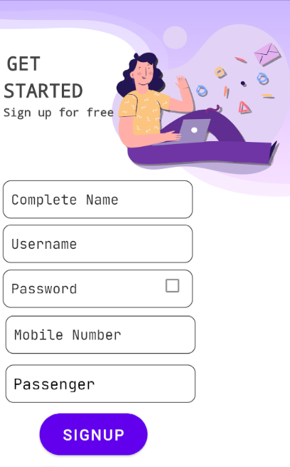

* ~~HOW TO LOGIN TO THE APP~~
* OPEN THE EZPAY APP
* INPUT YOUR USERNAME AND PASSWORD
* CLICK LOGIN BUTTON

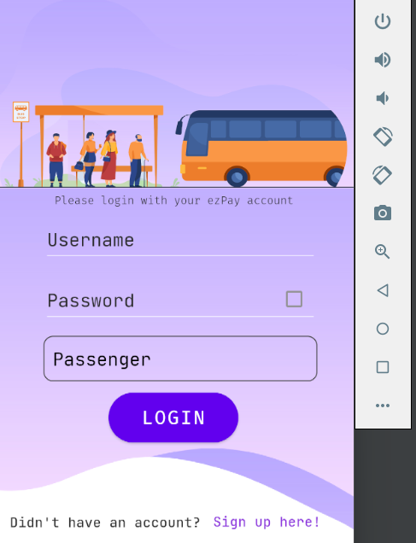

* HOW TO VIEW YOUR DATA AND TRANSACTIONS AS A PASSENGER
* LOGIN TO THE APPLICATION
* SELECT VIEW PROFILE IN THE MENU PAGE

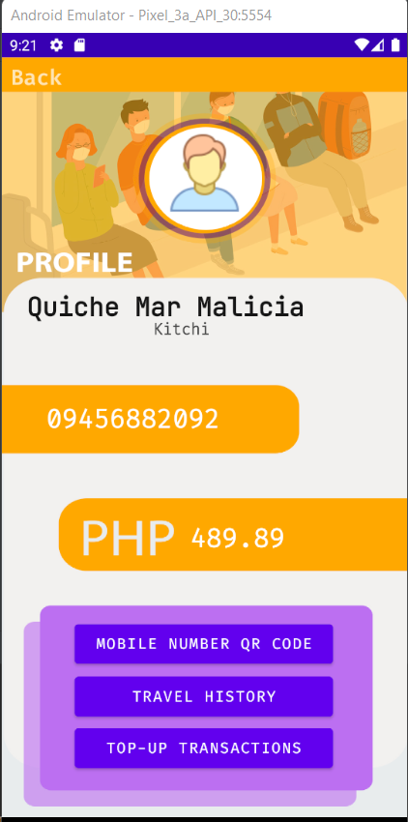

* HOW TO USE THE SIMULATION OF SHORTEST PATH FROM THE MENU
* HOW TO USE THE SIMULATION OF SHORTEST PATH FROM THE MENU
* INPUT TWO POINTS FROM THE GRAPHICAL PRESENTATION
* CLICK RUN

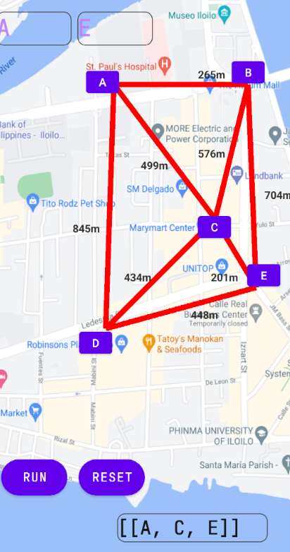

* HOW TO GENERATE YOUR TICKET
* SELECT GENERATE QR CODE FROM THE HOMEPAGE
* FIRST, INPUT YOUR INITIAL LOCATION IN THE TEXTFIELD
* SECOND, INPUT YOUR DESIRED DESTINATION
* NEXT, SELECT THE TYPE OF TRANSPORTATION YOU'LL USE
* THEN SELECT WHAT TYPE OF PASSENGER YOU ARE
* SELECT COMPUTE BUTTON
* SELECT PAY VIA QR BUTTON
* SELECT GENERATE QR CODE BUTTON

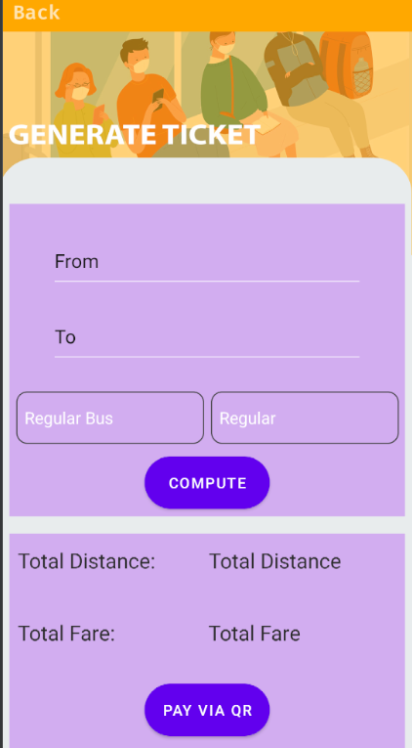

* HOW TO VIEW YOUR PERSONAL DATA AS A DRIVER
* LOGIN TO THE APPLICATION
* SELECT VIEW PROFILE IN THE MENU PAGE



* HOW TO COLLECT PAYMENT FROM THE PASSENGER
* SELECT COLLECT PAYMENT
* SCAN THE QR CODE OF THE PASSENGER
* CONFIRM THE TICKET

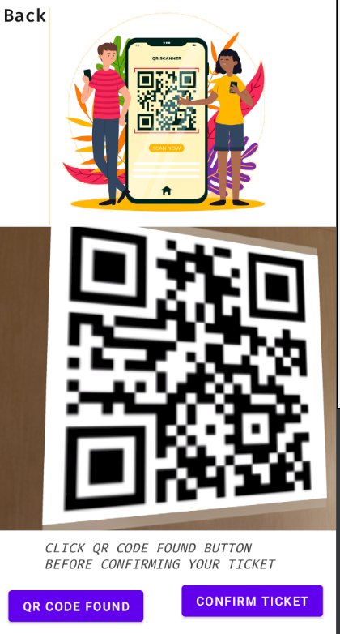

1. Top-up System

* HOW TO LOGIN TO THE APP AS A CASHIER
* OPEN THE TOP-UP SYSTEM
* INPUT YOUR USERNAME AND PASSWORD AND YOUR USERTYPE
* 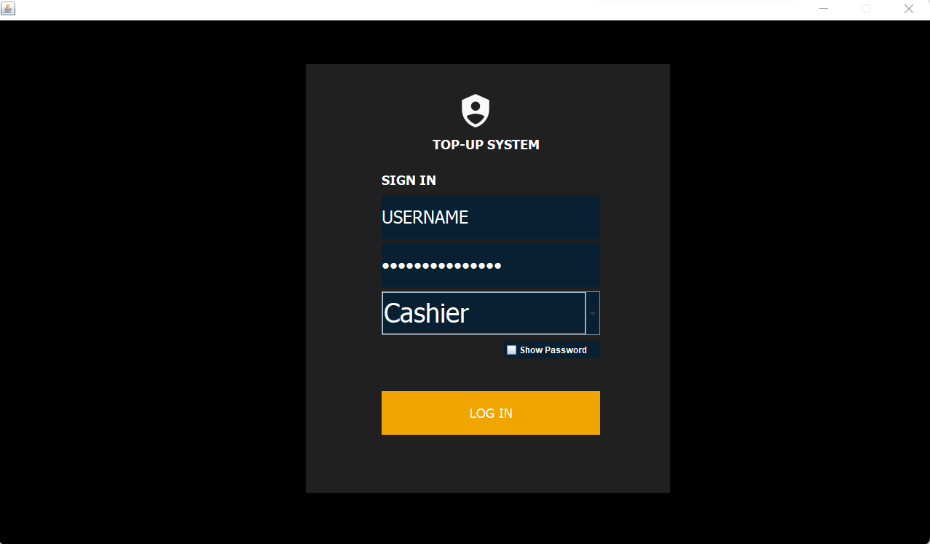CLICK LOGIN
* HOW TO USE THE TOP-UP OR ADD LOAD FUNCTION(CASHIER)
* SELECT THE ADD LOAD BUTTON FROM THE DASHBOARD
* INPUT THE MOBILE NUMBER OF THE PASSENGER
* INPUT THE TOP-UP AMOUNT
* CONFIRM THE TOP UP

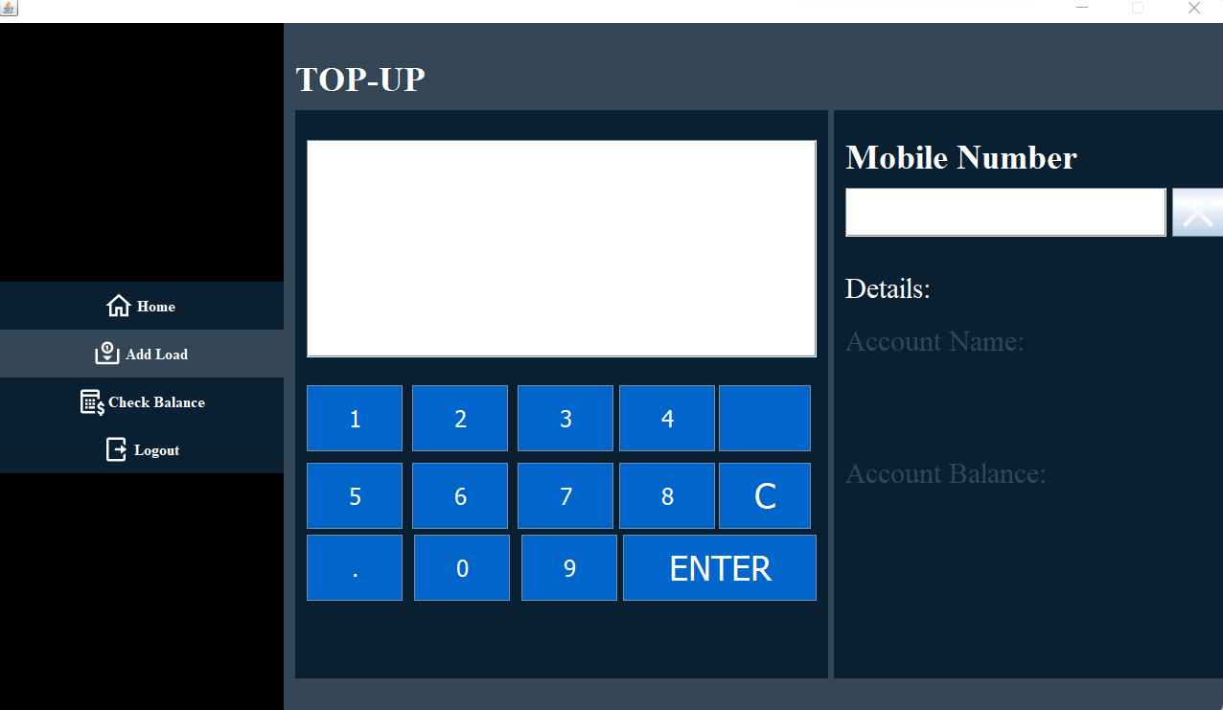

* HOW TO CHECK THE BALANCE OF THE PASSENGER (CASHIER)
* SELECT THE CHECK BALANCE BUTTON FROM THE DASHBOARD
* INPUT THE MOBILE NUMBER OF THE PASSENGER
* PRESS ENTER

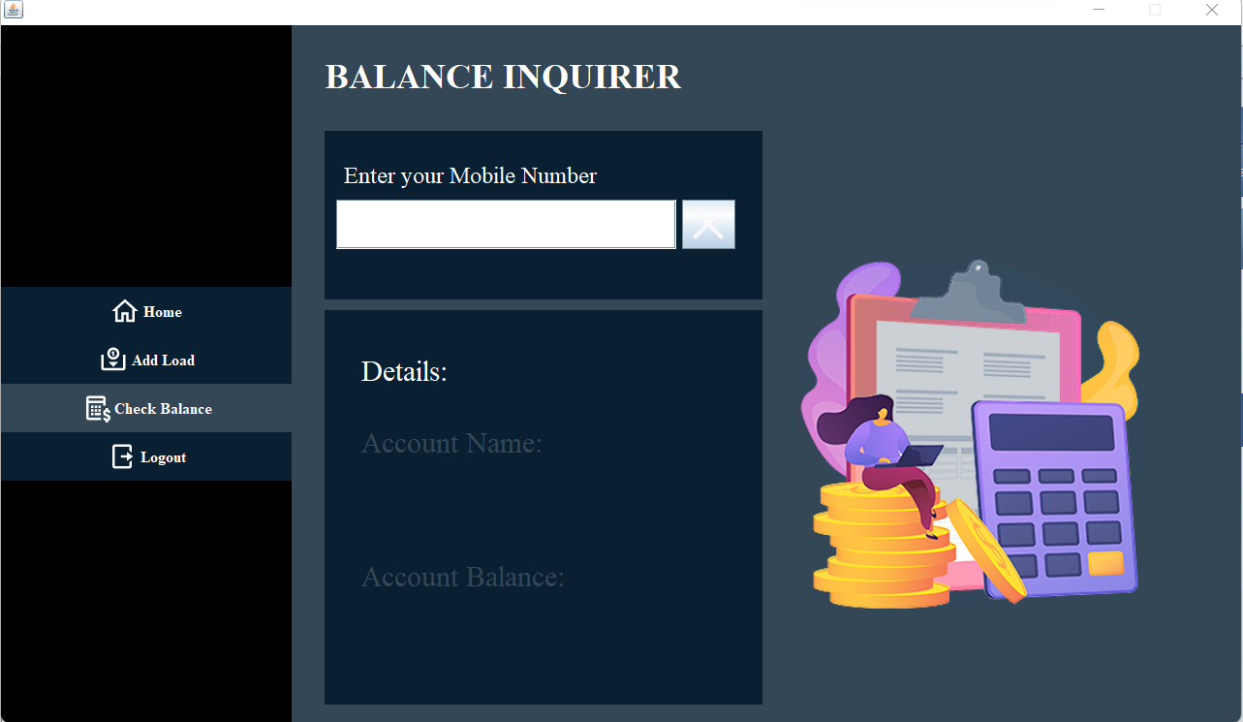

* HOW TO LOGIN TO THE APP AS A MANAGER
* OPEN THE TOP-UP SYSTEM
* INPUT YOUR USERNAME AND PASSWORD AND YOUR USERTYPE
* CLICK LOGIN

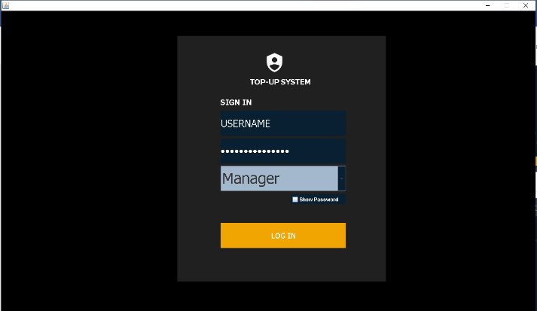

* HOW TO VIEW TRANSACTIONS FROM TOP-UP SYSTEM
* LOGIN TO THE TOP UP SYSTEM
* SELECT TRANSACTION BUTTON FROM THE DASHBOARD

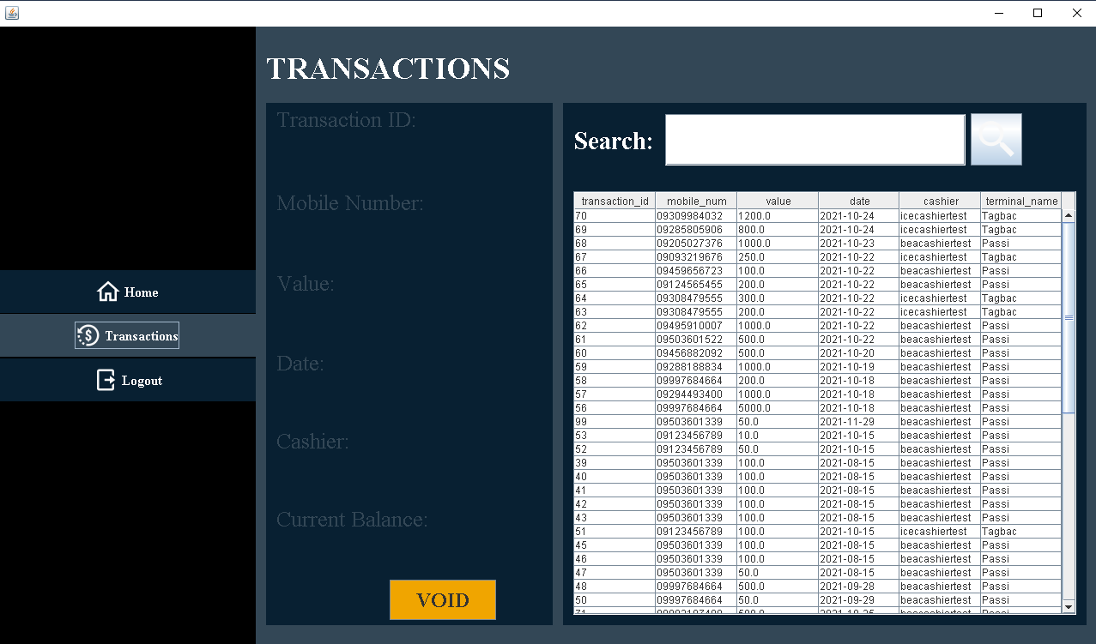

* HOW TO VOID TRANSACTION
* SELECT A ROW FROM A TABLE
* CLICK VOID TRANSACTION THEN CONFIRM IT.

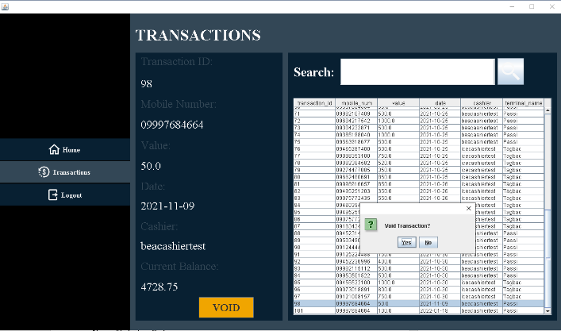

1. Fare Management System

* HOW TO LOGIN TO THE APP AS AN ADMINISTRATOR
* OPEN THE FARE MANAGEMENT SYSTEM
* INPUT YOUR USERNAME AND PASSWORD
* CLICK LOGIN

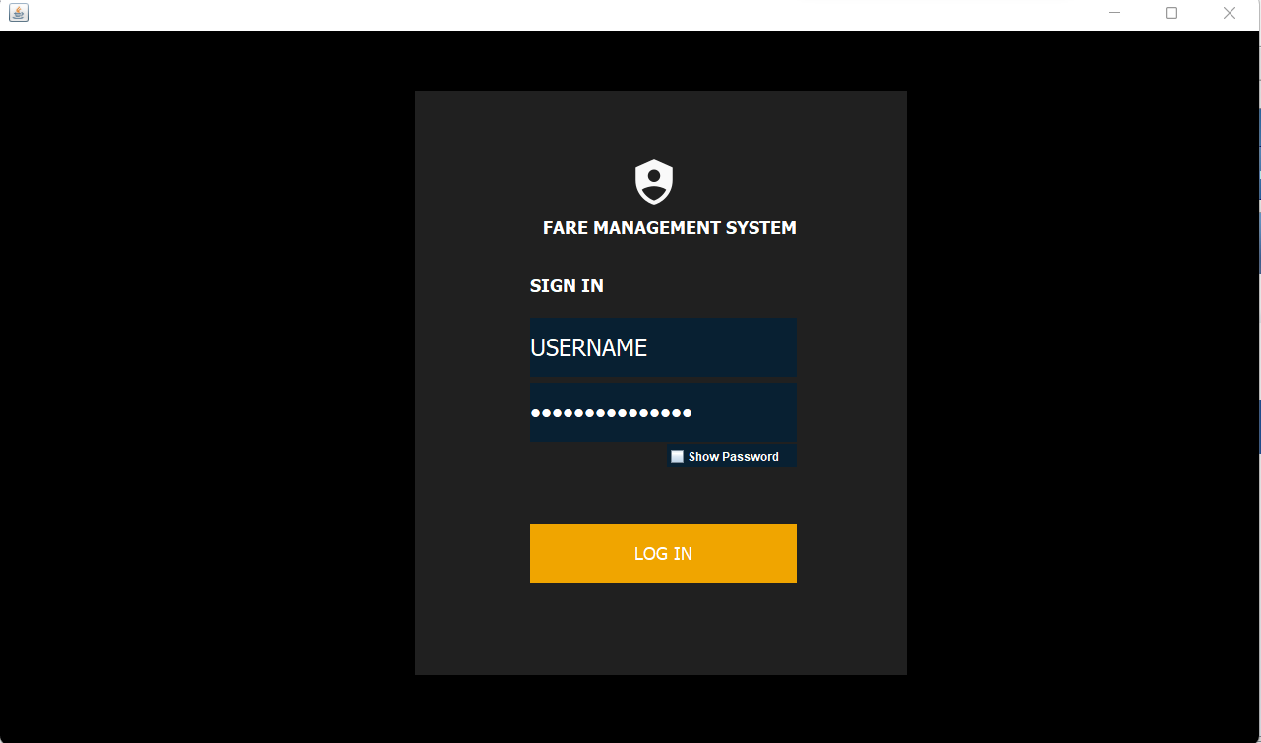

* HOW TO VIEW TOTAL SALES GAINED BY THE TOP-UP SYSTEM
* FROM THE DASHBOARD SELECT SALES IN THE MENU

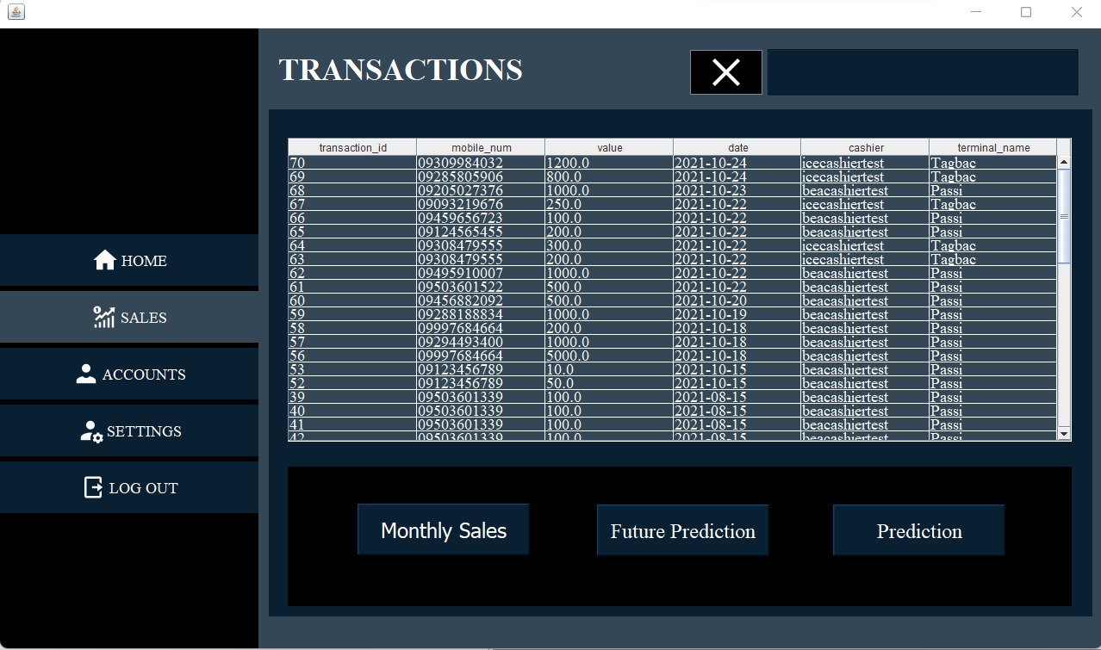

* HOW TO VIEW MONTHLY SALES GAINED BY THE TOP-UP SYSTEM
* FROM THE DASHBOARD SELECT SALES IN THE MENU
* CLICK MONTHLY SALES

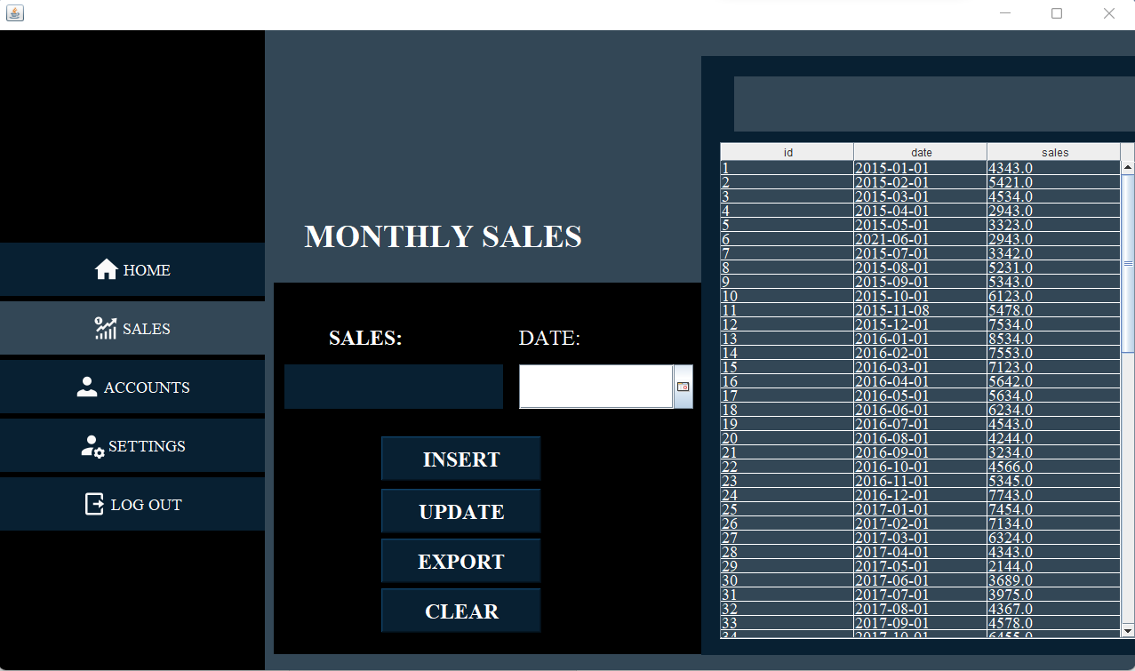

* HOW TO MANAGE MONTHLY SALES
* CLICK INSERT TO ADD MONTHLY SALES
* CLICK UPDATE IF YOU WANT TO UPDATE A SPECIFIC SALES
* CLICK EXPORT TO EXPORT TABLE AS CSV FILE FOR RECORDING PURPOSES



* HOW TO VIEW THE VISUAL REPRESENTATION OF SALES AND FUTURE SALES PREDICTION
* FROM THE DASHBOARD SELECT SALES IN THE MENU
* SELECT SALES PREDICTION OR FUTURE SALE PREDICTION
* SELECT A SPECIFIC COLUMN FROM THE TABLE
* CLICK SHOW

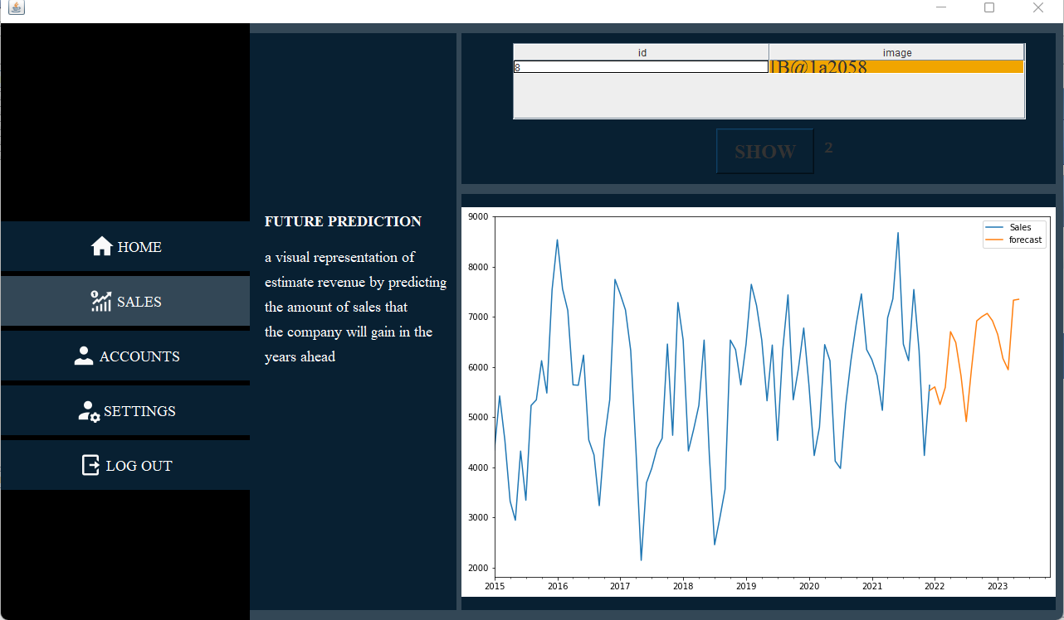

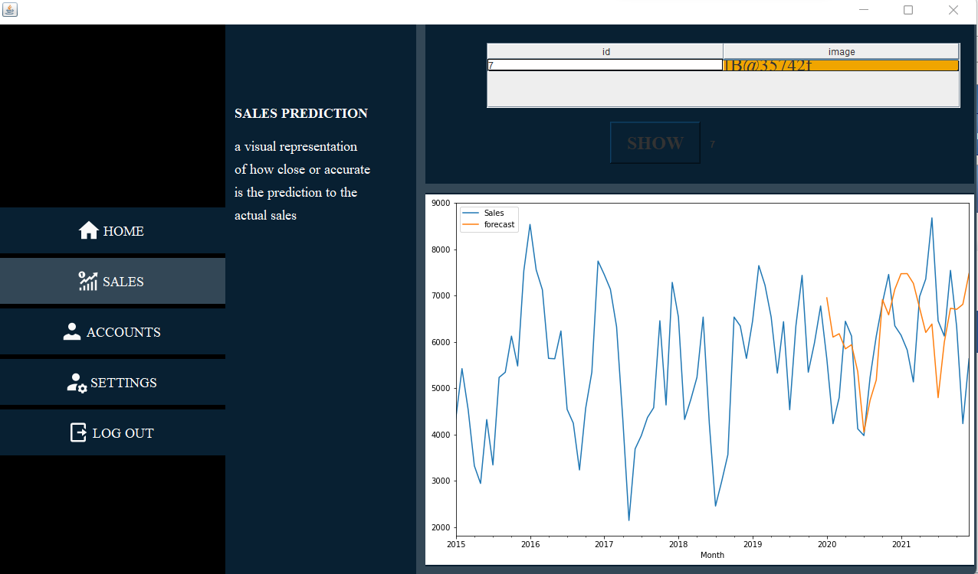

* HOW TO MANAGE USER OF TOP- UP SYSTEM
* FROM THE DASHBOARD SELECT ACCOUNTS
* FILL UP NECESSARY DETAILS
* SELECT ADD USER TO ADD NEW USER
* SELECT A SPECIFIC COLUMN FROM THE TABLE TO REMOVE OR UPDATE A CERTAIN USER

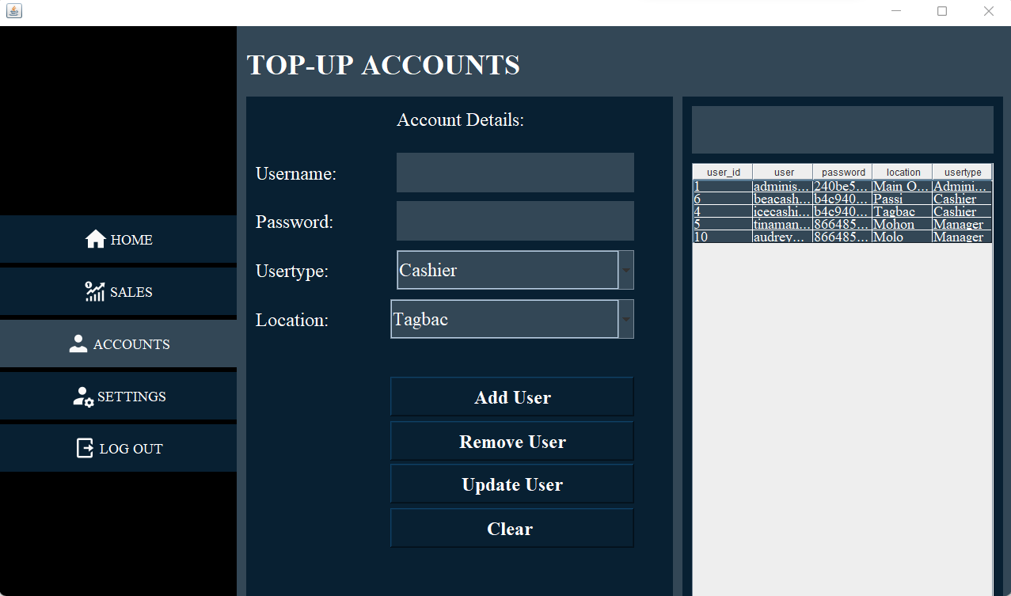

* HOW TO MANAGE USER OF FARE MANAGEMENT SYSTEM
* FROM THE DASHBOARD SELECT SETTINGS IN THE MENU
* FILL UP NECESSARY DETAILS
* SELECT ADD ADMINISTRATOR TO ADD NEW ADMIN
* SELECT A SPECIFIC COLUMN FROM THE TABLE TO REMOVE AN ADMINISTRATOR

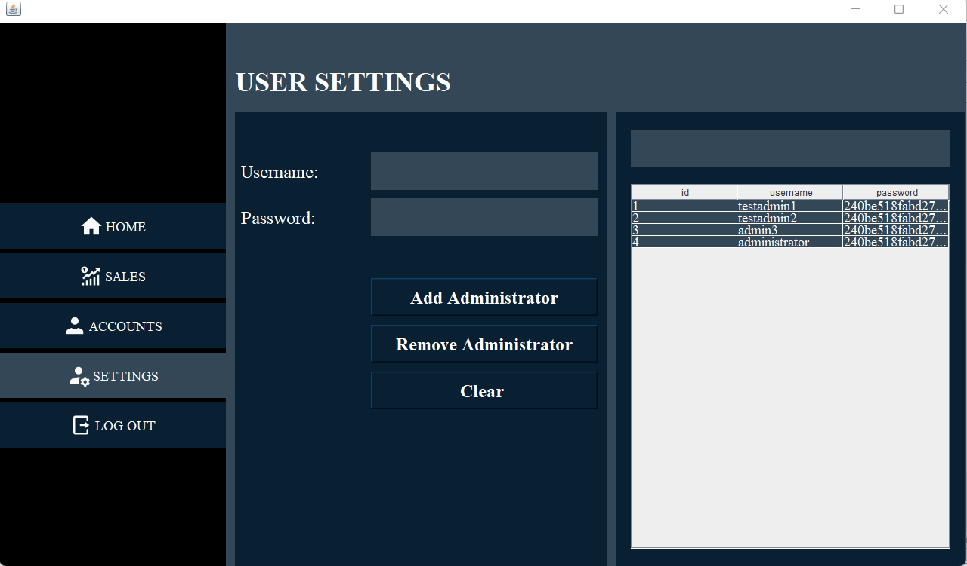

TROUBLESHOOTING FOR FIXING POSSIBLE BUGS

|  |  |  |
| --- | --- | --- |
| Developer Error Code | Type | Description |
| BillingNotEnabledMapError | Google API Error | You have not enabled billing on your project which is causing this error. You must enable Billing on the Google Cloud Project |
| ExpiredKeyMapError | Google API Error | The API key included in the script element has expired or is not recognized by the system. You may receive this error after creating a new API if you try to use the key before it is recognized by the system. Wait a few minutes and try again, or you may need to generate a new API key in the Cloud Console. |
| InvalidKeyMapError | Google API Error | The API key included in the script element that loads the API is not found. Please make sure you are using the correct API key. You can generate a new API key in the Cloud Console. |
| InvalidKey | Google API Error | The API key included in the script element that loads the API does not look correct. Please make sure you are using the correct API key. You can generate a new API key in the Cloud Console. |
| CommunicationsLinkFailure | Database Error | The driver has not received any packets from the server. You need to connect to a stable internet connection to connect to the server. |
| java.security.cert.CertPathValidatorException: Trust anchor for certification path not found. | SSL Certificate Error | In this case, the SSLHandshakeException occurs because you have a CA that isn't trusted by the system. The developers included a function that allows all SSL certificates. |

**FREQUENTLY ASKED QUESTIONS (FAQ)**

**Is the Mobile App secure?**

Yes! All critical information is encrypted and no personal information is stored on your mobile device. However, mobile devices do offer you the ability to store your login information for apps installed on the device. If you choose to store your login information, any person who has access to your mobile device can access your account.

**What features does the Mobile App have?**

The mobile app has the ability to generate your ticket if you are a passenger and can also provide a visual representation of the shortest path using the dijkstra algorithm. Also for the driver the mobile app has the ability to collect the payment of the passenger as well as can view the visual representation of shortest path using the dijkstra algorithm.

**What is the main use of the system?**

The main purpose of this system is to automate the manual fare collection system and to provide an accurate, cashless and efficient mode of transportation.

**How Dijkstra Algorithm works?**

Dijkstra's Algorithm basically starts at the node that you choose (the source node) and it analyzes the graph to find the shortest path between that node and all the other nodes in the graph. The algorithm keeps track of the currently known shortest distance from each node to the source node and it updates these values if it finds a shorter path. Once the algorithm has found the shortest path between the source node and another node, that node is marked as "visited" and added to the path. The process continues until all the nodes in the graph have been added to the path. This way, we have a path that connects the source node to all other nodes following the shortest path possible to reach each node.

**How Haversine Algorithm works?**

The haversine formula determines the great-circle distance between two points on a sphere given their longitudes and latitudes. Important in navigation, it is a special case of a more general formula in spherical trigonometry, the law of haversines, that relates the sides and angles of spherical triangles.

**Is Haversine Formula accurate?**

Consequently, the Haversine formula can result in an error of up to 0.5%. To address this, Thaddeus Vincenty developed a very complicated formula that is accurate up to 0.5mm, making it the ultimate geodesic formula for all serious scientific purposes.

**CONTACT DETAILS OF THE DEVELOPMENT TEAM**

**Name:** Bea Merr S. Recabar

**Address:** Ponong Grande, Duenas, Iloilo

**Phone number:** 09503601339

**Email Address:** recabarbm@gmail.com

**Name:** Audrey Salcedo

**Address:** Ponong Grande, Duenas, Iloilo

**Phone number:** 09997684664

**Email Address:** [dreydevs26@gmail.com](mailto:dreydevs26@gmail.com)

**Name:** Tina Marie Santisteban

**Address:** Brgy. San Rafael, Miagao, Iloilo

**Phone number:** 09104104615

**Email Address:** katrinalouisenarida@gmail.com

**Name:** Clarice Jane Darle

**Address:** Brgy. Alegria, Dingle, Iloilo

**Phone number:** 09308479555

**Email Address:** lavenderwings9599@gmail.com